Trombinoscopes

Lycée Toulouse Lautrec

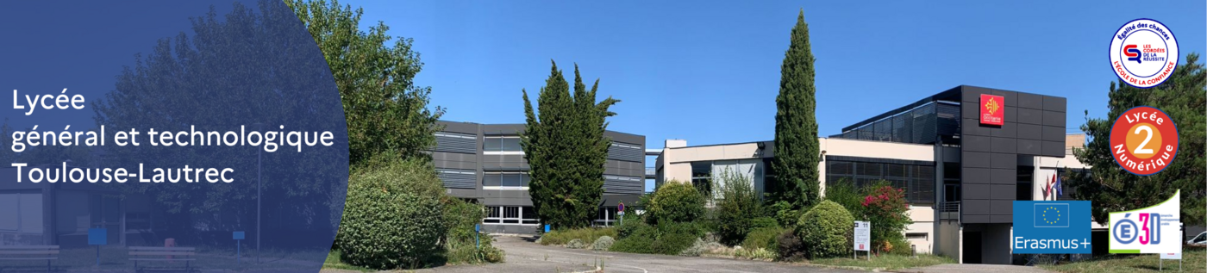

2024-2025
Thibaud DIDIER

